What is App-V Sequencer?

- The App-V Sequencer (part of Microsoft Application Virtualization, or App-V) is a wizard-based tool that captures and records an application's installation and setup processes to package it into a virtualized format. This results in package files such as .SFT, .OSD, .ICO, and .SPRJ, which can be deployed and run on client machines without traditional installation.
- It is a core component of Microsoft App-V, which enables applications to run in isolated “bubbles”, avoiding conflicts with other apps or the operating system and simplifying centralized deployment.

Why Use App-V Sequencer?

- Conflict Reduction: Multiple versions of an application can coexist without interfering.
- Simplified Deployment and Rollback: Virtual applications can be deployed centrally and easily rolled back or updated.
- Improved Compatibility: Legacy apps can be virtualized without altering the host OS.

Installing Microsoft App-V Sequencer
Step 1: Download Windows ADK
- Go to the Microsoft website: Windows ADK Download
- Download the Windows Assessment and Deployment Kit (ADK) installer for your Windows version.

Step 2: Run the ADK Installer
- Double-click the downloaded ADK setup file.
- Select Install the Windows Assessment and Deployment Kit to this computer.
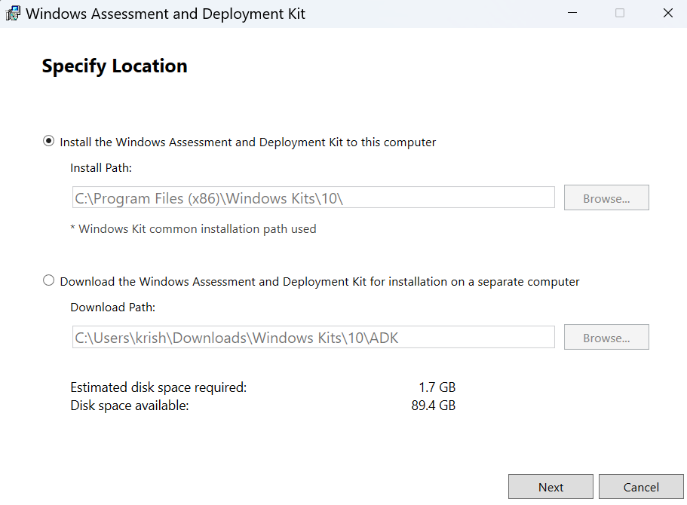
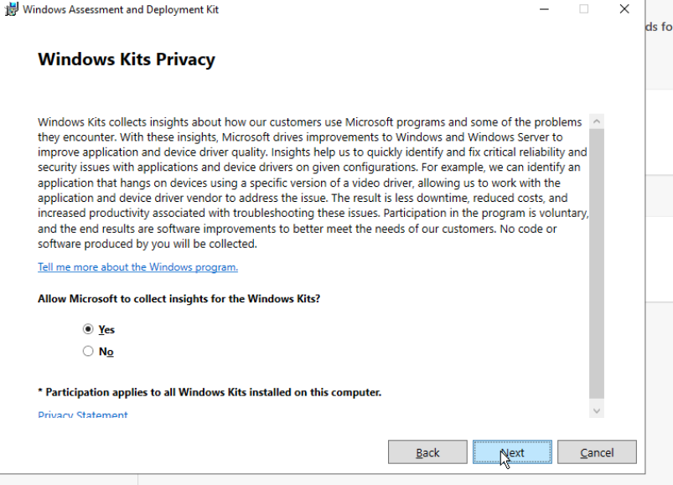
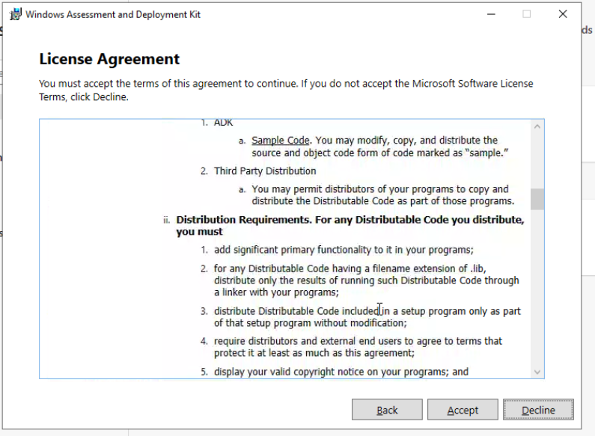
Step 3: Select Components
- When prompted to choose features, check the option for:
  - Microsoft Application Virtualization (App-V) Sequencer
- You may also install additional tools if required.
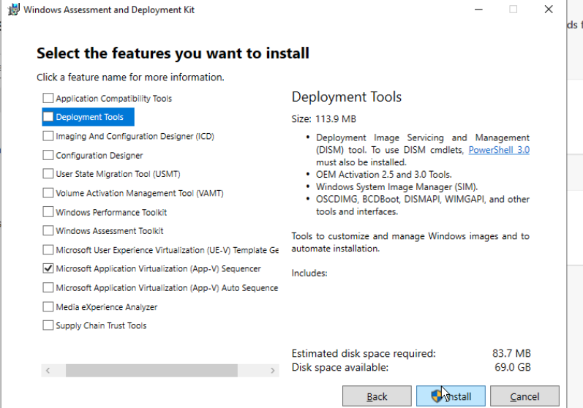

Step 4: Install on a Clean Machine
- Make sure you install on a clean machine (fresh Windows setup, no extra apps).
- Ensure App-V Client is NOT enabled on this machine.

Step 5: Complete Installation
- Click Install and wait for the setup to finish.
- Once done, click Close.
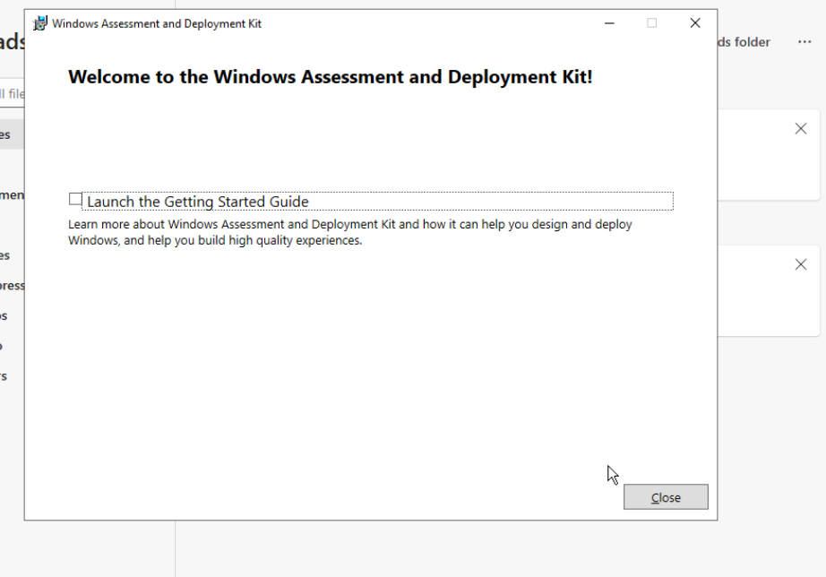
Step 6: Launch App-V Sequencer
- Open the Start Menu.
- Search and launch Microsoft Application Virtualization (App-V) Sequencer.
